
North Bengal International University

Lab Report: 09
Exp Name : A program to implementation the Fibonacci series using C language.

Subject : Data Structure
Subject Code : CSE 0612-2131

Submitted By:
Name : Md. Tanvir Rahman Pranto
Dept : CSE
Roll : 0712340012101005
Semester : 2nd Year, 4th semester.

Submitted To:
Name : Saifur Rahman
Designation : Lecturer
Dept : CSE
Date :

Code:
#include <stdio.h>

int main() {
int n, a = 0, b = 1, c, i;

printf("Enter how many numbers you want in Fibonacci series: ");
scanf("%d", &n);

printf("Fibonacci Series:\n");

if (n >= 1) {
printf("%d ", a);
}
if (n >= 2) {
printf("%d ", b);
}

i = 3;
while (i <= n) {
c = a + b;
printf("%d ", c);
a = b;
b = c;
i = i + 1;
}

return 0;
}

Output:
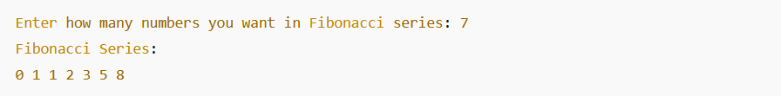

Conclusion: This simple C program generates the Fibonacci series using basic loops and variables, without using any functions. It's a beginner-friendly approach that helps understand how values are updated and repeated in a sequence using simple logic and control flow.

